**IT221 Project**

**Section: 4i2**

|  |  |
| --- | --- |
| **Student Name** | **Student ID** |
| Rana Ebraheem Al-Saadan | 444009087 |
| Dona Khalid Alabdullatif | 444008955 |
| Lama shaiban alshaiban | 444009259 |
| Lena Ahmed Alfaifi | 444009202 |
| Shahla Suliman Alnassar | 444009230 |
| Jana Fahad Al-Thumairy | 444009078 |

TABLE OF CONTENTS

Tasks distribution 2

Introduction 2

Performing a ping: 3

Sharing folder (create a new folder and then share it during the discussion): 4

Sharing printer (you do not need to bring your printer to the discussion just illustrate the steps and show the screen-shots in the report). 5

Download one voice or video call programs and one chatting program designed for LAN network to test your *network.(Without using the internet)* 6

Control other node using Remote Desktop application (from one laptop to another one in your network using either Windows OS features or downloading a software). 7

Use "tracert" command to trace the route for the URL web page (enable the Internet). What does "tracert" do? show screen shot 8

Problems 9

References 9

# 

# **Tasks distribution**

|  |  |
| --- | --- |
| **Student Name** | **Task** |
| Rana Ebraheem Al-Saadan | Worked on everything. |
| Dona Khalid Alabdullatif | Worked on everything. |
| Lama shaiban alshaiban | Worked on everything. |
| Lena Ahmed Alfaifi | Worked on everything and responsible for printer. |
| Shahla Suliman Alnassar | Worked on everything. |
| Jana Fahad Al-Thumairy | Worked on everything. |

# **Introduction**

We made the network by turning the internet off from all devices, then connecting them to the switch by using ethernet cables, after that we changed the IP addresses of all devices and performed a ping to ensure that all devices were connected.

The softwares we used were:

1. LAN messenger for chatting.
2. Beebeep or TeamViewer for voice calls and messages.
3. TeamViewer for controlling the screen of the other device.

The type of topology used was Star topology because each device is connected to a central hub, which is a switch.

# **Performing a ping:**

We configured the devices' IP addresses to be static so that it is manual to each device and changed the IP for each one. Then in Run CMD, we wrote each IP to ensure they are connected to communicate.

LAPTOP 1:

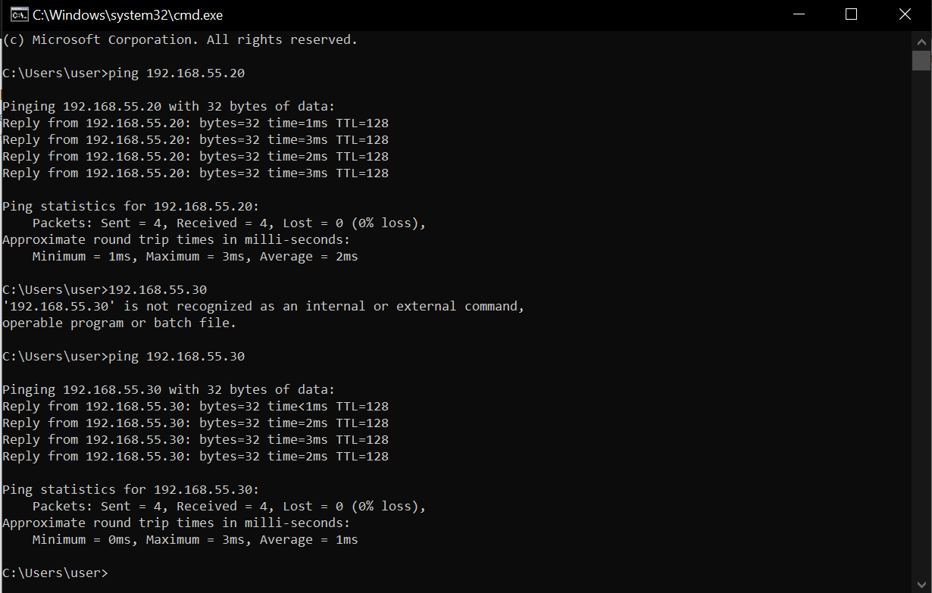

LAPTOP 2:

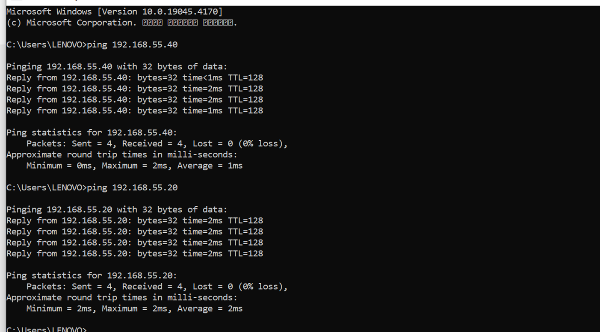

LAPTOP3:

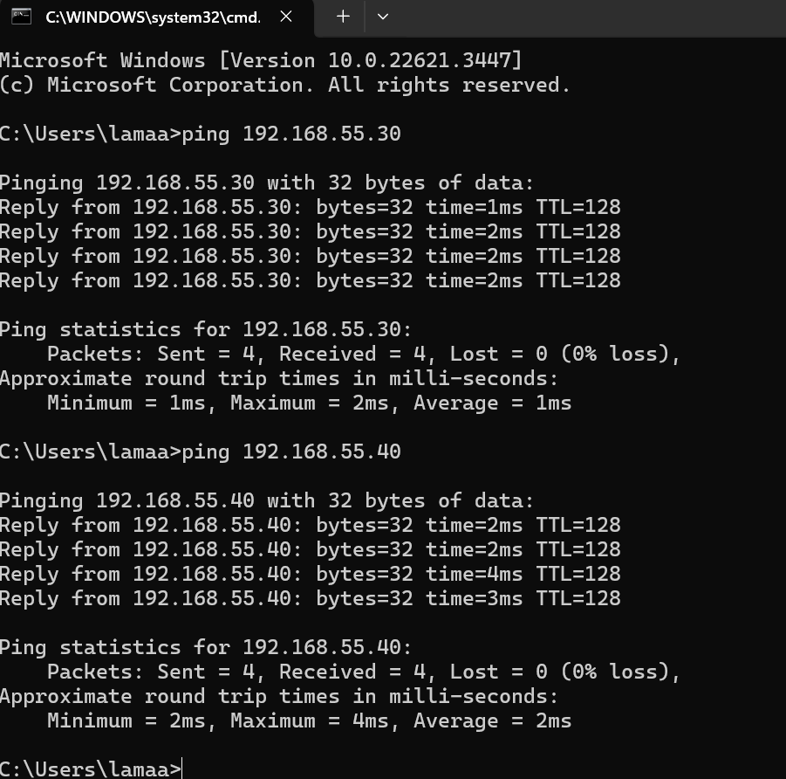

# **Sharing folder (create a new folder and then share it during the discussion):**

We shared the folders by changing the properties so every device in the network could read and not modify it.

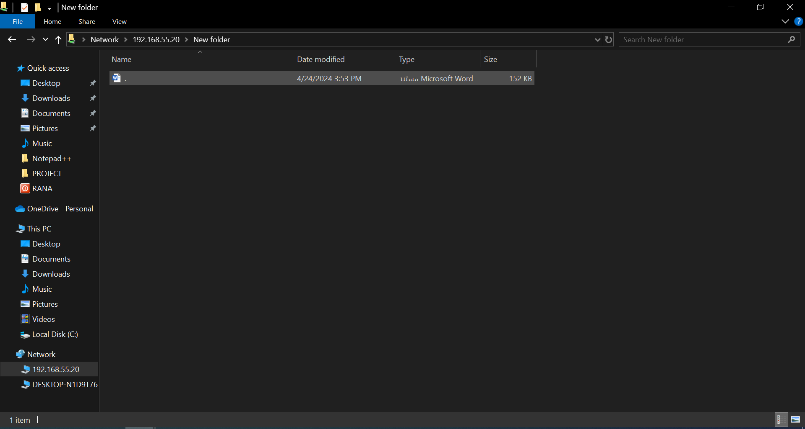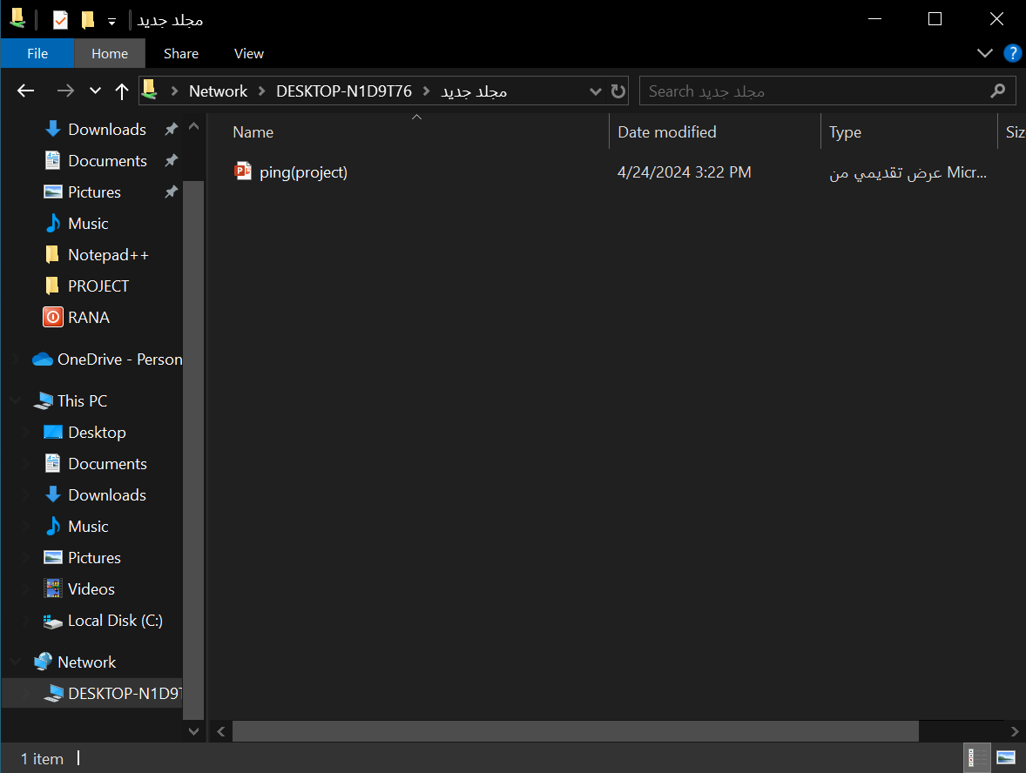LAPTOP 1:

LAPTOP 2:

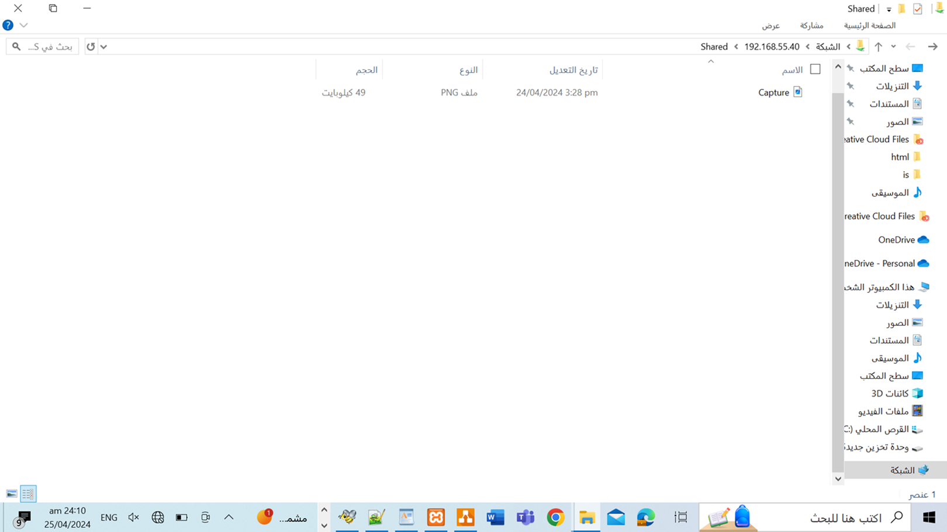

LAPTOP 3:

# **Sharing printer (you do not need to bring your printer to the discussion just illustrate the steps and show the screen-shots in the report).**

The printer is connected to one device which is connected to the other and by sharing the printer with that device it appeared on it and we connected to the printer.

# **Download one voice or video call programs and one chatting program designed for LAN network to test your *network.(Without using the internet)***

By downloading the programs for LAN networks, we opened the apps and used them to see the devices and call or send messages and voice recordings to the devices apparent on the program.

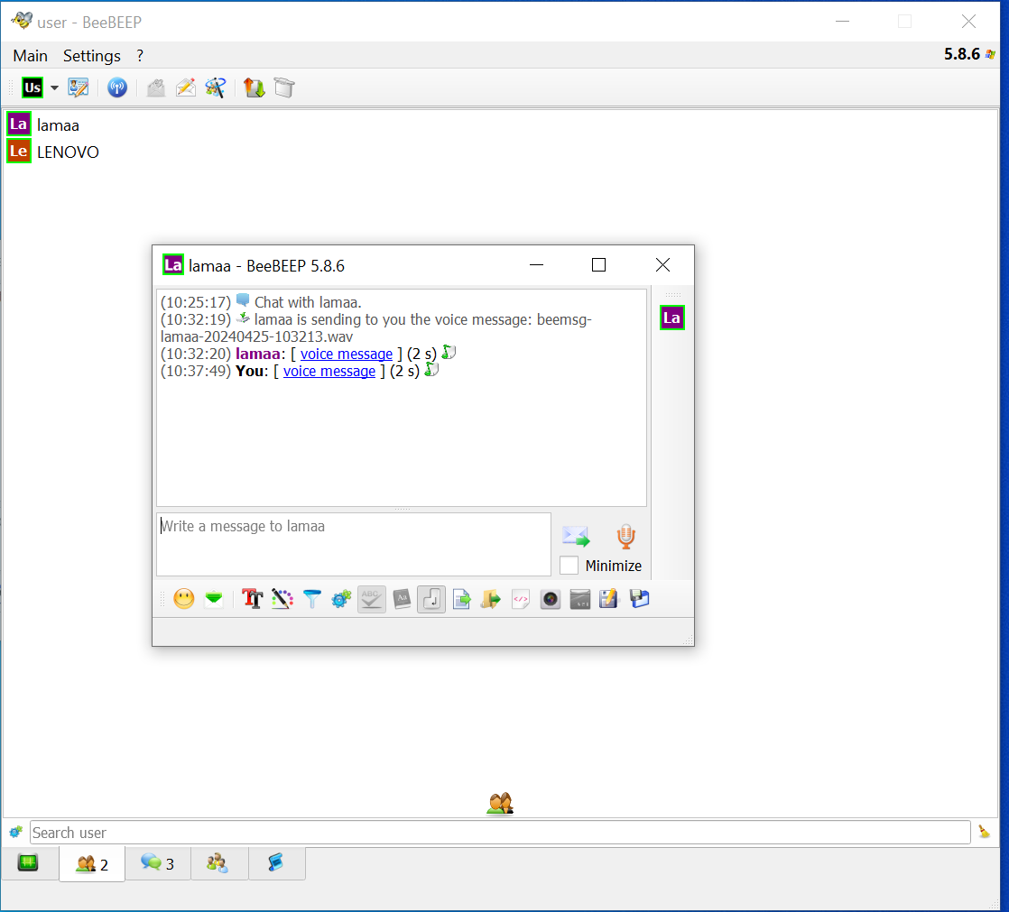LAPTOP 1:

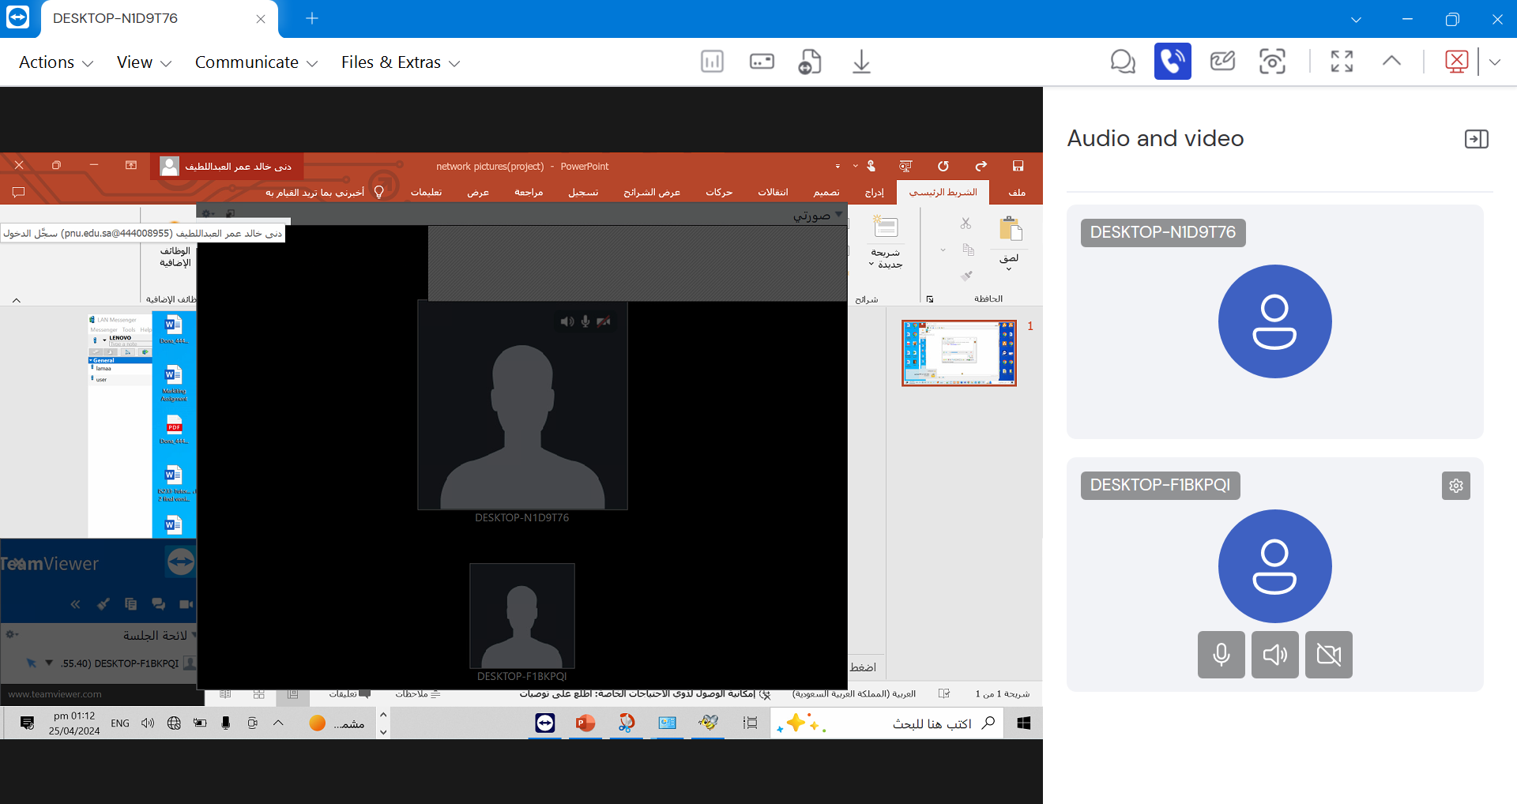

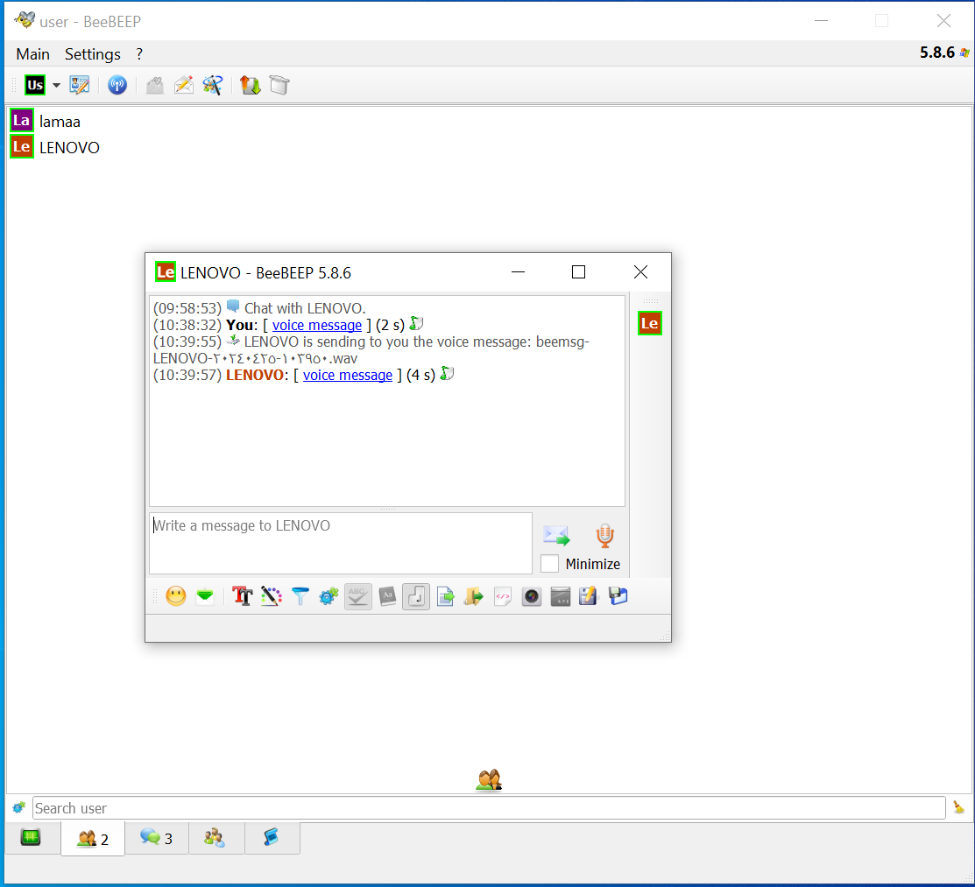

LAPTOP 2:

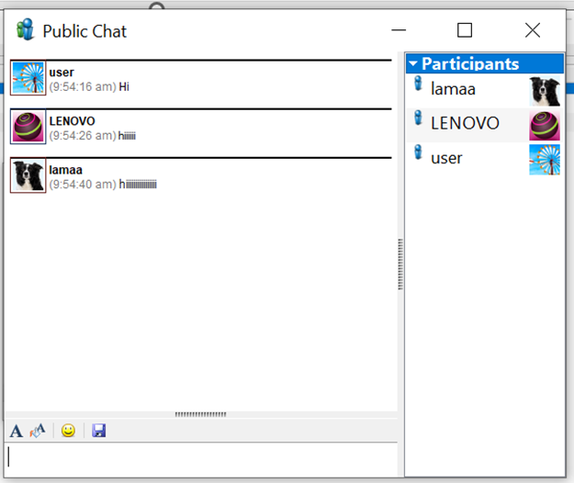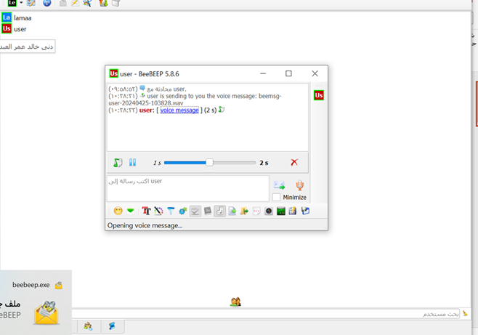  
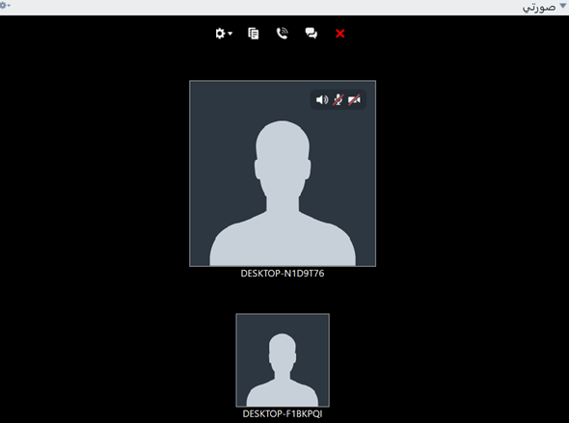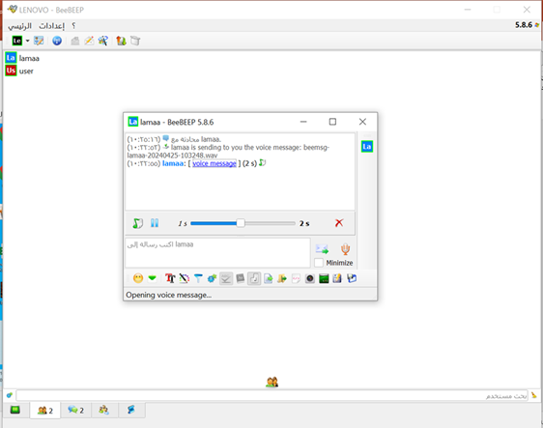

LAPTOP 3:

**

# **Control other node using Remote Desktop application (from one laptop to another one in your network using either Windows OS features or downloading a software).**

We can control the device in the call by the program by the IP address and the password shown on the first page of the program.

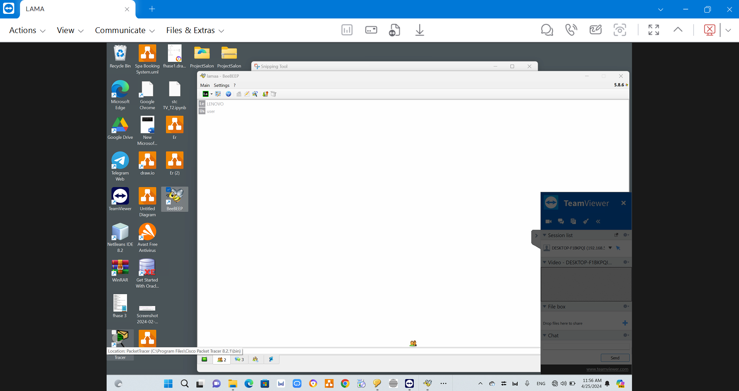LAPTOP 1:

LAPTOP 3:

# **Use "tracert" command to trace the route for the URL web page (enable the Internet). What does "tracert" do? show screen shot**

**Tracert** traces the route of packets that take between a device to a specific host just like a map but on data and how it travels from the source to its final destination and shows the number of hops between them, the time that’s taken, as well as the IP addresses of routers which helps in troubleshooting network problems, identifying bottlenecks and verifying network paths.

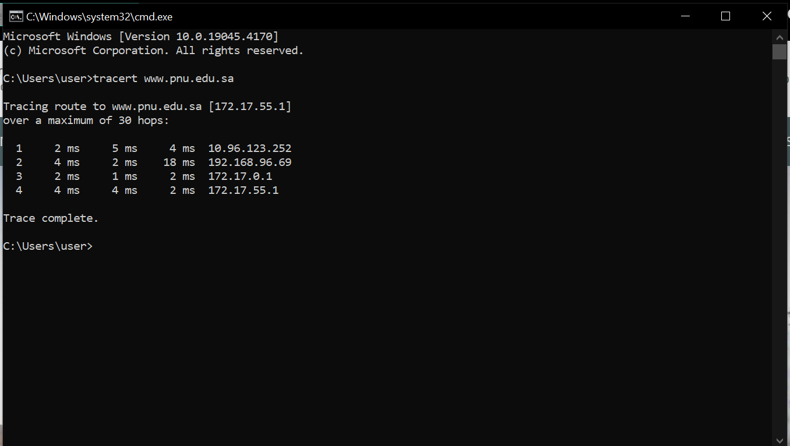LAPTOP 1:

LAPTOP 2:

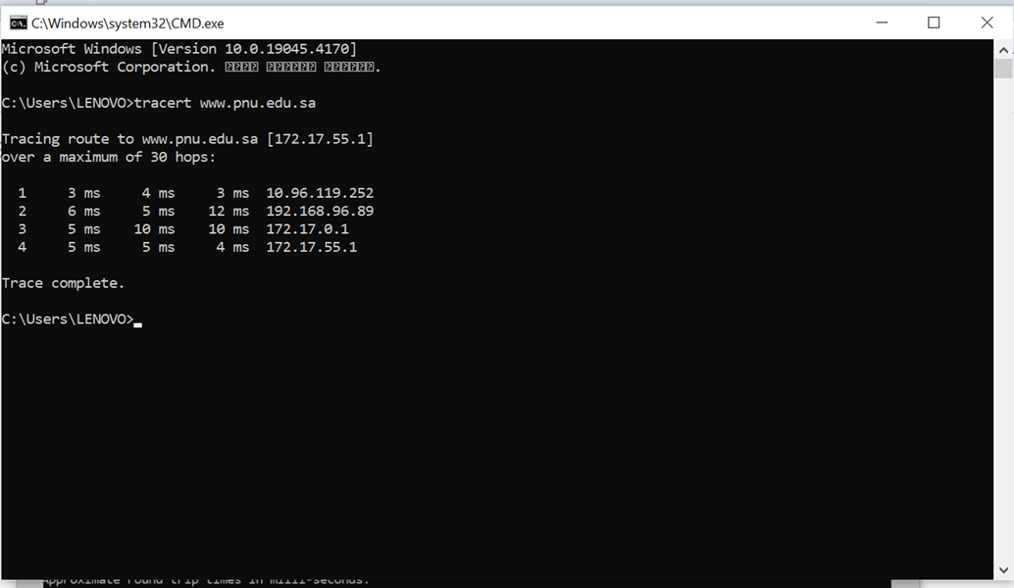

LAPTOP 3:

**Problems**

Destination hosts unreachable & general failure: we disconnected the wires, restarted the laptop, and then changed the ETHERNET IP and the ping then it worked correctly.

Sharing folders as not all laptops were shown so we used the run application and put "\\" slash with the IP of the device we want to share to and it was fixed.

# **References**

1. PagerDuty. (2021). How to ping a network for testing connectivity. Available at: https://www.pagerduty.com/resources/learn/ping-network-testing-connectivity/ (Accessed: May 3, 2024).
2. Microsoft. "File Sharing over a Network in Windows." Microsoft Support. Available at: https://support.microsoft.com/en-us/windows/file-sharing-over-a-network-in-windows-b58704b2-f53a-4b82-7bc1-80f9994725bf (Accessed: May 3, 2024).
3. Microsoft. "Share your network printer." Microsoft Support. Available at: https://support.microsoft.com/en-us/windows/share-your-network-printer-c9a152b5-59f3-b6f3-c99f-f39e5bf664c3#:~:text=Select%20and%20hold%20(or%20right,printer%20from%20a%20secondary%20PC. (Accessed: May 3, 2024).
4. Quora. "How do I make video calls over a LAN without an internet?" Available at: https://www.quora.com/How-do-I-make-video-calls-over-a-LAN-without-an-internet (Accessed: May 3, 2024).
5. Microsoft. "How to use Remote Desktop". Available at: https://support.microsoft.com/en-us/windows/how-to-use-remote-desktop-5fe128d5-8fb1-7a23-3b8a-41e636865e8c (Accessed: May 3, 2024).
6. N4L Support. "How to use Tracert (Traceroute)". Available at: https://support.n4l.co.nz/s/article/How-to-use-Tracert-Traceroute (Accessed: May 3, 2024).